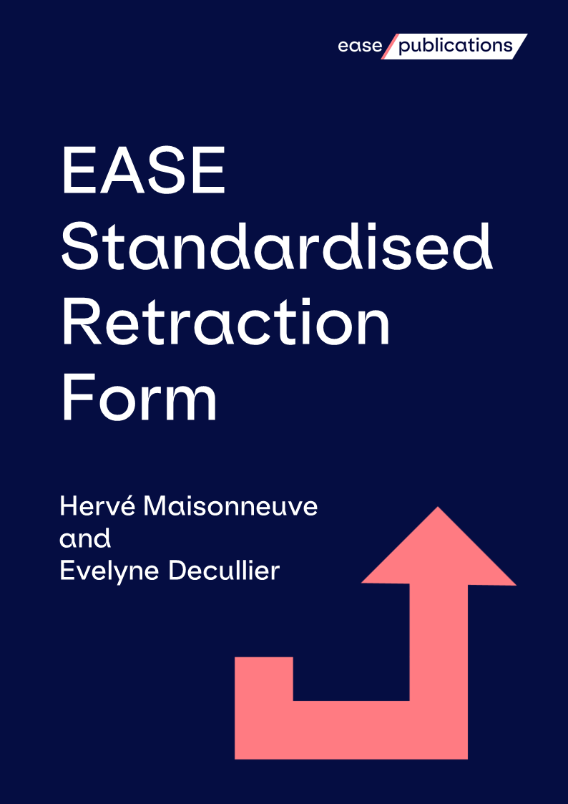
This retraction template checklist was designed to support editors when preparing a retraction notice, and help researchers analyse retractions.
This template helps editors and journal managers understand whether an article meets the pre-requisites for the COPE retraction guidelines¹.
The form consists of tick boxes and space for supporting clarification, to indicate who is retracting the article, the reason for the retraction and history of errata/ expressions of concern. A free text box allows the editor to add any information they consider useful, and a final Retraction Notice box is provided to summarise the details in the form into text to be published to announce the retraction.
This form was first created in June 2015, by Hervé Maisonneuve and Evelyne Decullier and most recently updated in June 2022.
Introduction
Find more EASE Statements, Guidelines and Resources on the EASE Publications web pages:
https://ease.org.uk/publications/

References
1. COPE Council. COPE Guidelines: Retraction Guidelines. November 2019
https://doi.org/10.24318/cope.2019.1.4
Reference of the retracted article:
DOI:
Retraction Date:
 | Day | Month | Year
Retraction requested by (multiple responses allowed):
 | □ All Authors
 | □ Some of the Authors. Names:
 | □ Editor as requested by:
 | o Institution
 | o Reader
 | o Other (details)
 | □ Journal’s owner / publisher
Date of retraction request
 | Day | Month | Year
Retraction type (multiple responses allowed):
Invalidating the results*  *only one check mark is allowed in this column |  | Not invalidating the results
□ Fraud |  | □ Plagiarism
□ Inconsistent Data |  | □ Overlap
□ Honest error: |  | □ Property or legal concern
o Irreproducibility |  | □ Lack of ethical approval
o Lab error |  | □ Authorship
o Analytical error |  | □ Editorial reasons
o Other (details): |  | □ Approval issues (authors, editors)
 |  | □ Compromised peer review
 |  | □ Conflicts of interest
History
□ History of expression of concern
Previous incident reference and details:
□ History of correction.
Previous incident reference and details:
Additional comments and details
Retraction notice text (to be published)

Secretary / secretary@ease.org.uk
EASE website / ease.org.uk
Twitter / twitter.com/EASEeditors
LinkedIn / linkedin.com/company/easeeditors
Facebook / facebook.com/EASEeditors/
YouTube / youtube.com/c/EASEeditors
European Science Editing / ese.arphahub.com
European Science Editing Twitter / twitter.com/Eur_Sci_Ed
Secretariat and registered office:
The Brambles, Ryton Road, Dymock, Gloucestershire, GL18 2DG, UK
The European Association of Science Editors is a Company Limited by Guarantee. It is registered in England and Wales and the Company Number is 4049507. It is not registered for VAT.

