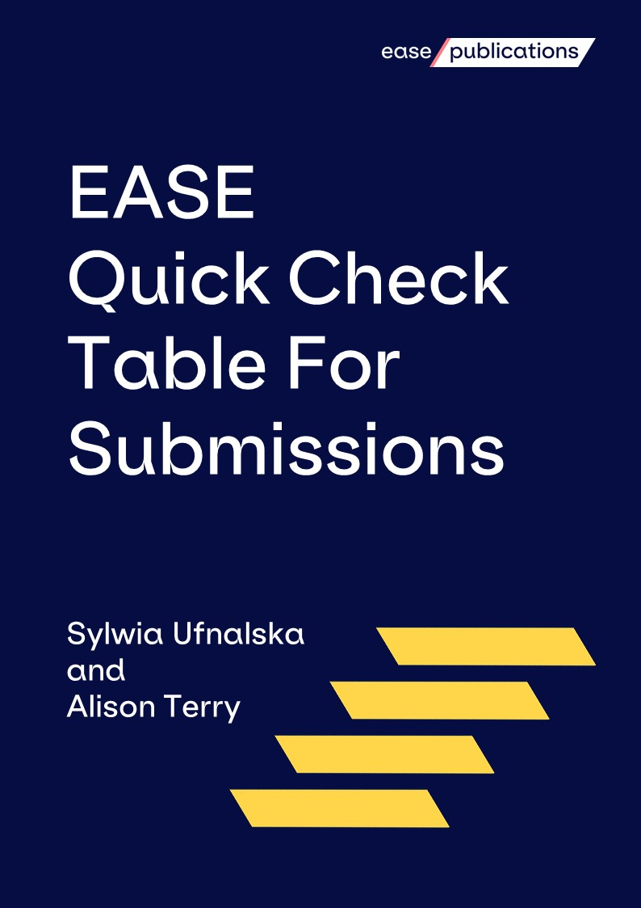
When preparing a scientific manuscript for submission to a journal, it is often time-consuming for authors to find the journal's specific preferences and requirements, many of which can influence immediate rejection or acceptance of a paper.
Submission guidance can be similarly tricky for journal editors too, for whom there are few convenient resources available to guide or standardise the presentation of instructions for authors and formatting guidelines.
The EASE Quick Check Table For Submissions is a template intended to make life easier for both authors and editors by summarising requirements into a simple table at the start of instructions for authors, clearly displaying the essential information that is required for the paper to move to the peer review process.
Introduction
How to use this table
The table includes spaces for the most commonly featured measures such as word count, number of keywords, format of tables and figures, reference style, journal policies and additional notes. This table is intended to be easily updated, for flexibility between journals, and for amendments to be made as journal preferences change.
Authors are encouraged to create one version of this table for each of their target journals, read the full author instructions of each and update this form with the full submission requirements to check against during the writing process, and before submission to ensure compliance before uploading or sending files to the editors.
Journal editors are encouraged to develop the core features of this table into the full set of styles, formats and requirements they wish to use for their journal. Journals may make a version of this table available for authors to help format and check their articles before submission.
This form was first created in September 2020 by Sylwia Ufnalska and Alison Terry, in cooperation with other EASE member editors, and published as a proposal in EASE journal, European Science Editing¹. Updated in April 2023 by Duncan Nicholas.
Definitions for models of open peer review are taken from Defining Open Peer Review: Part Two - Seven Traits of OPR by Tony Ross-Hellauer²
The Quick Check Table For Submissions can be found on the EASE website: https://ease.org.uk/publications/ease-statements-resources/quick-check-table-for-submissions/
More EASE Statements, Guidelines and Resources are available on the EASE Publications web pages: https://ease.org.uk/publications/
References
- Ufnalska S, Terry A (2020) Proposed universal framework for more user-friendly author instructions. European Science Editing 46: e53477. https://doi.org/10.3897/ese.2020.e53477
- Ross-Hallauer T (2016) Defining Open Peer Review: Part Two - Seven Traits of OPR. OpenAIRE, 02 Nov 2016 . https://www.openaire.eu/blogs/defining-open-peer-review-part-two-seven-traits-of-opr-1

Quick Check Table

GENERAL GUIDELINES | Manuscripts should be COMPLETE, CONCISE and CLEAR (see EASE Guidelines, available in many languages).  Follow the appropriate reporting guidelines where applicable.
WORD LIMITS, etc.
Body text
Original articles
<other article types>
Abstract
Original articles
<other article types>
Keywords
Original articles
<other article types>
Highlights/ Key Message
(below the abstract)
Tables/figures
Original articles
<other article types>
TITLE PAGE INFORMATION
Title
Short running title
Author names
Affiliation information required
Corresponding author contact details
Persistent identifiers of author(s), etc.
STRUCTURE OF BODY TEXT, END MATTER, REFERENCES
Typical headings
Original articles
<other article types>
Subheadings
Specific wording required for any section
End matter
(e.g. authorship contributions)
References
maximum number
Original articles
<other article types>
Referencing style
FORMATTING
Spelling
General style
SUBMISSION NOTES
Cover letter
Required?
Specific details to be mentioned?
Links to all required author forms
needed at submission or after acceptance?
Signed by all authors or by submitting author?
Proposed reviewers Optional / mandatory?
How many?
What details are required?
Tables
Required as separate files?
Figures
Required as separate files?
Any formats preferred?
Supplementary files
Fees and payments
For open access, colour images, pages etc.?
JOURNAL POLICIES, etc.

Publication model
(Subscription / hybrid / full open access?)
Preprint and prepublication
Data sharing
Peer review model*
(Single- / Double- / Triple- anonymised / Open review?)
Manuscript acceptance / rejection rate
Peer review and production times
Citation and Alternative Metrics
ADDITIONAL DETAILS
Use this space to provide details of any features or requirements of note that do not fit any other categories of this table
* Peer review systems:
Anonymised review models:
- Single-anonymised: authors do not know the identity of reviewers
- Double- anonymised: neither authors or reviewers know the identity of each other
- Triple- anonymised: same as double, with the addition editors do not know the identity of authors/institution
Open review models
- Open identities: Authors and reviewers are aware of each other's identity
- Open reports: Review reports published alongside the relevant article
- Open participation: The wider community contribute to the review process
- Open interaction: Direct reciprocal discussion between author(s) and reviewers, and/or between reviewers, is allowed and encouraged
- Open pre-review manuscripts: Manuscripts are made immediately available (e.g., via pre-print servers like ArXiv) in advance of any formal peer review procedures
- Open final-version commenting: Review or commenting on final “version of record” publications
Open platforms: Review is de-coupled from publishing in that it is facilitated by a different organizational entity than the venue of publication

Secretary / secretary@ease.org.uk
EASE website / ease.org.uk
Twitter / twitter.com/EASEeditors
LinkedIn / linkedin.com/company/easeeditors
Facebook / facebook.com/EASEeditors/
YouTube / youtube.com/c/EASEeditors
European Science Editing / ese.arphahub.com
European Science Editing Twitter / twitter.com/Eur_Sci_Ed
Secretariat and registered office:
The Brambles, Ryton Road, Dymock, Gloucestershire, GL18 2DG, UK
The European Association of Science Editors is a Company Limited by Guarantee. It is registered in England and Wales and the Company Number is 4049507. It is not registered for VAT.
EASE, 2023. This work is licensed under a Creative Commons Attribution Share Alike Licence (CC BY-SA 4.0). Users can reproduce material from this guide under the same conditions as the materials are made available.

